**JKUAT-KSA Small Scale Agriculture Crop Mapping Project**

**Research Methodology: Project Workflow**

The approach used in our Small Scale Crop Mapping research project is adapted from [the engineering design process](https://www.twi-global.com/technical-knowledge/faqs/engineering-design-process). The steps towards developing a working crop mapping and analytics system (mobile application, web application and server side technologies) are presented below.

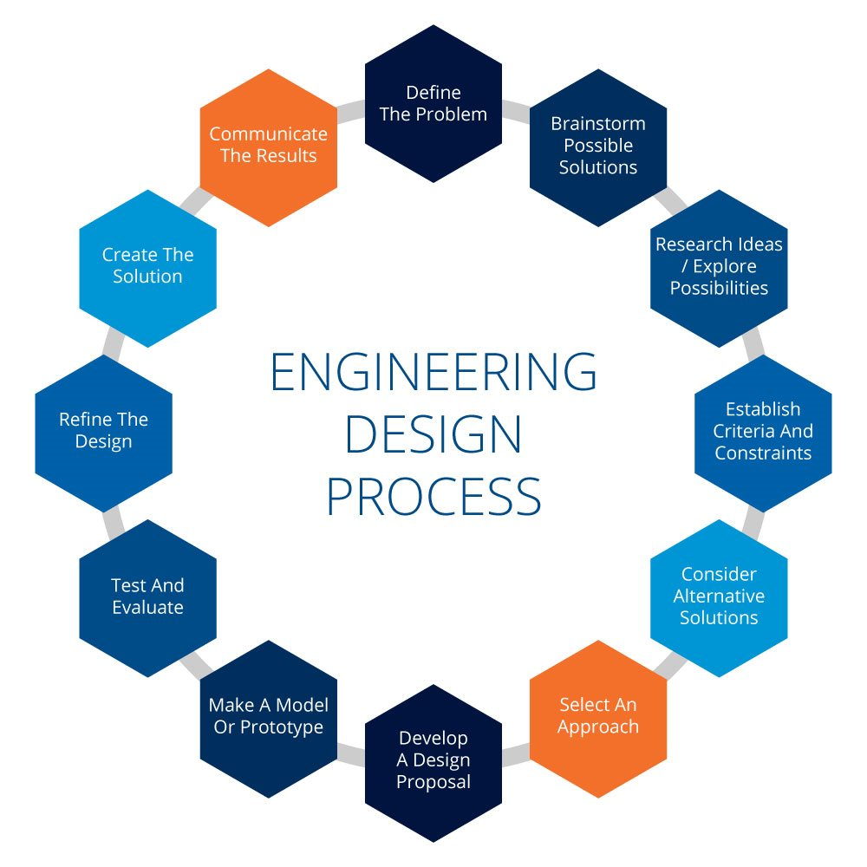

1. **Problem definition**

This involves identifying the problem at hand (food security), general system requirements and the targeted users of the product (farmers, policy makers and GIS experts).



1. **Literature review and research**

This step involved carrying out extensive research on similar projects, in the domains of crop mapping, remote sensing for crop analytics, AI, ML and GIS Development. Looking into previous literature allows the researchers to gain better understanding of the problem, explore possibilities and avoid problems encountered by others. This stage involved performing a detailed survey of existing farming applications such as <cropmonitoring.eos.com>, OneSoil app, Plantix and Agroptima to analyze their functionalities and shortcomings.

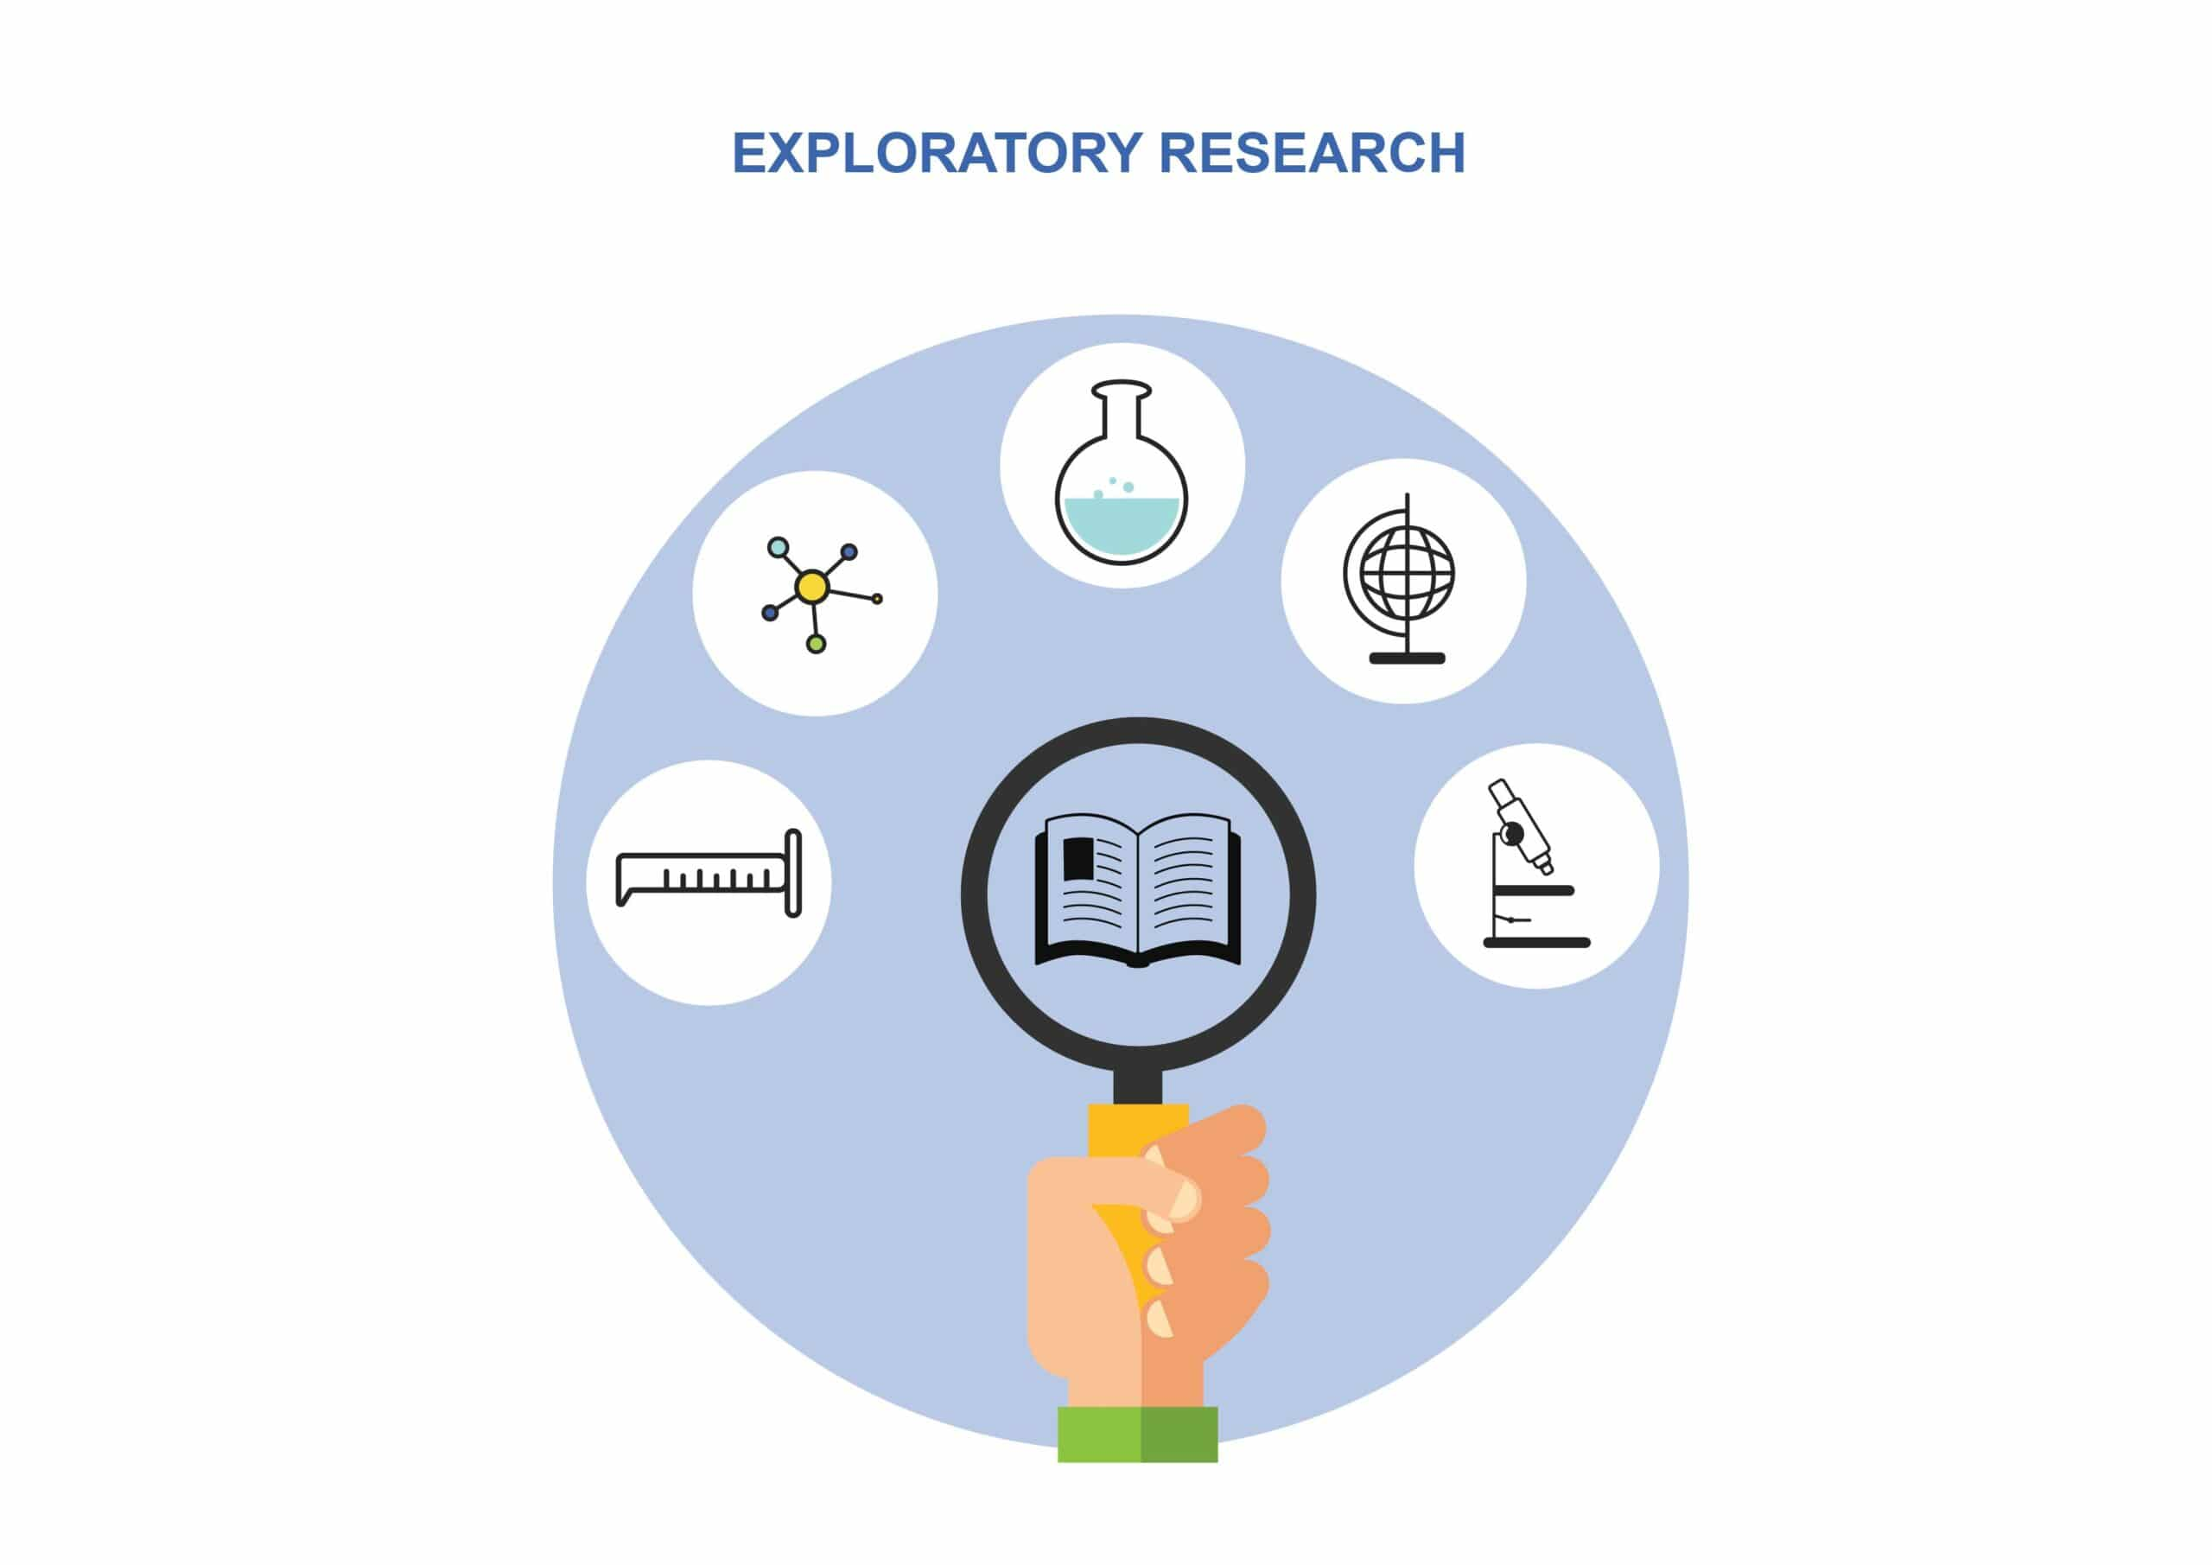

1. **Needs assessment**

All the needs of the project, including the system requirements, user needs, data and storage requirements were considered. Extensive literature review gave useful insights of these requirements. In this case, the researchers were required to develop a system with a GUI, for use by farmers, GIS experts and policy makers for crop mapping and analytics. The different user needs were considered for all user classes. For example, farmers generally need to access information about weather history and forecast, soil properties, pest and disease control and the performance of their crops. Policy makers include civil servants in the agricultural sector, and related cabinet secretaries. They require processed data about crop yields, soil properties and climate for larger regions such as counties, in order to make informed decisions concerning farming. GIS experts require to use the platform for acquisition, storage, manipulation and retrieval of the data required by the farmers and policy makers. Data acquisition and storage requirements, such as satellite imagery acquisition procedures, research and validation data requirements were also considered. A conceptualized design was then developed.

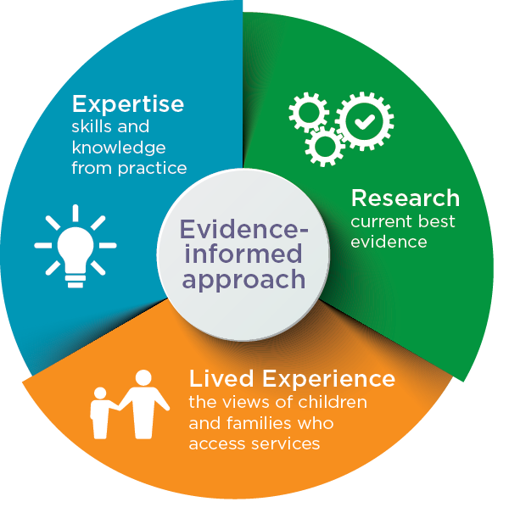

1. **Establishing a work plan**

This was done by revisiting the requirements and the KSA Terms of Reference to develop the flow of the project. The best approach towards achieving all the required aspects of the project were selected. Tasks were divided to highly specialized segments to be achieved individually, such as GEE script writing and supervised classification, back and front end app development sides, literature review requirements, research and design work, among others. Timelines for the tasks were guided by the use of a Gantt Chart developed by the team, before assembling the parts into a working system. 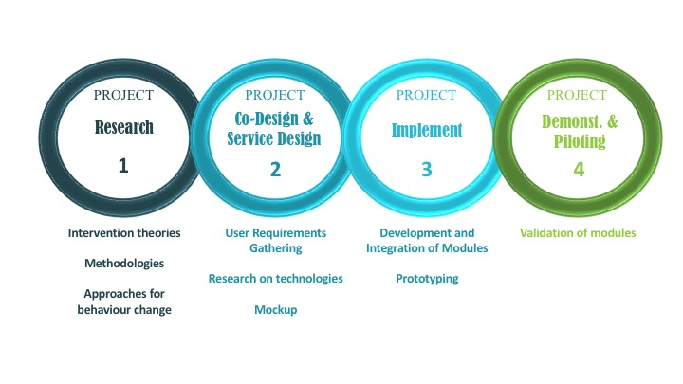

1. **Developing the system model**

In this stage, the conceptualized design proposal was used to create a system prototype that allowed the researchers to test the functionality and performance of the final product. UI/UX designs were developed to represent the anticipated functionalities of the final applications. The development of the actual product started, and a prototype of a lesser standard was made. It involved the development of a mock mobile and web application to visualize the appearance, functionality and interactivity of the final product.

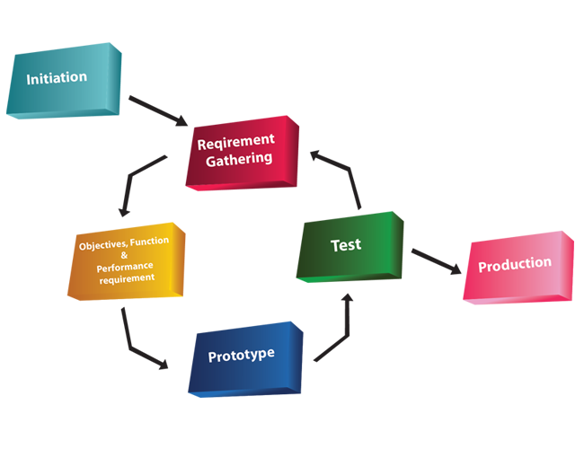

1. **Testing, Evaluation Refinement and Validation**

Each of the models underwent testing, evaluation and improvement where it was considered necessary. This was done repeatedly throughout the project until a suitable product was achieved. The application functions and GUI were evaluated until they fulfilled all the requirements.

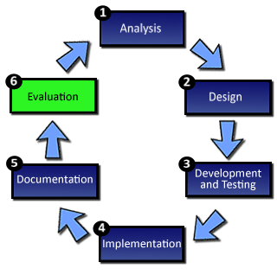

Ground validation of the data was also carried out using high resolution imagery of the study area, and a field work project created and managed on the SW Maps Application. Field work was carried out for further validation and collection of crop attribute information. The researchers familiarized the farmers with the application prototypes and recorded their reviews to make adjustments in the development process.

1. **Finished product**

With satisfactory testing and refinement, the final product was created, in form of a polished system prototype. Both (mobile and web) applications underwent the testing.

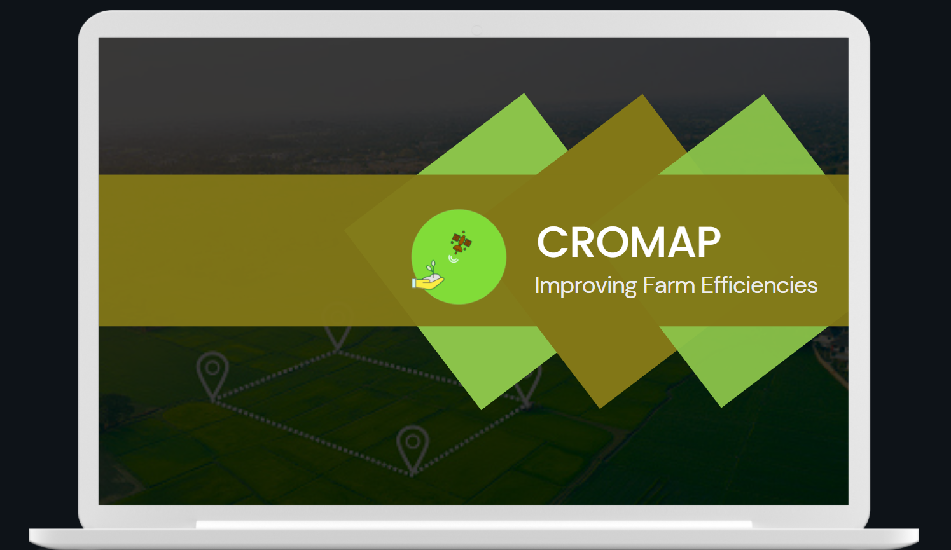

1. **Results Presentation and Adoption**

The product is presented to Kenya Space Agency, including thorough documentation of the working system. This allows for adoption of the system by other users and processing to the required quality standards.

